ASSIGNMENT Due on 20-01-2025 Assignments submitted after 3:15 am will not be accepted Answer the short questions

1. What are the parameters of a machining operation that are included within the scope of cutting conditions?

Parameters of Machining Operations: The parameters included within the scope of cutting conditions in a machining operation are:

Cutting speed: The speed at which the cutting tool engages the workpiece.

Feed rate: The distance the tool advances during each revolution or pass.

Depth of cut: The thickness of the material being removed in a single pass.

1. Explain the difference between roughing and finishing operations in machining.

Roughing operations focus on removing large amounts of material quickly to shape the workpiece, often resulting in a rough surface finish with visible tool marks. They use higher feed rates and cutting depths.

Finishing operations, on the other hand, aim to achieve a smooth surface finish and precise dimensions, using lighter cuts and lower feed rates to refine the workpiece.

1. What is an orthogonal cutting operation?

Orthogonal Cutting Operation: An orthogonal cutting operation is characterized by a cutting tool that engages the workpiece at a constant angle, typically perpendicular to the cutting surface. This type of cutting minimizes friction and allows for easier analysis of forces and chip formation.

1. Identify the two forces that can be measured in the orthogonal metal cutting model.

Forces in Orthogonal Metal Cutting Model: The two primary forces that can be measured in the orthogonal metal cutting model are:

Cutting force: The force required to remove material from the workpiece.

Radial force: The force acting perpendicular to the cutting edge, which can influence tool wear and stability.

1. What is the specific energy in metal machining?

Specific Energy in Metal Machining: Specific energy in metal machining refers to the energy consumed per unit volume of material removed. It is a measure of the efficiency of the machining process and is influenced by factors such as cutting speed, feed rate, and depth of cut.

1. How does a boring operation differ from a turning operation?

Boring vs. Turning Operations:

Boring operations involve enlarging existing holes or creating precise diameters in a workpiece using a single-point cutting tool.

Turning operations, however, involve rotating the workpiece against a stationary cutting tool to shape it into cylindrical forms.

1. What is meant by the designation 12 x 36 inch lathe?

Designation 12 x 36 Inch Lathe: The designation "12 x 36 inch lathe" indicates that the lathe can accommodate workpieces with a maximum diameter of 12 inches and a maximum length of 36 inches. This specification helps users understand the size limitations for machining operations.

1. How does a turret lathe differ from an engine lathe?

A turret lathe is designed for repetitive production runs, featuring multiple tools mounted on a rotating turret for quick changes between operations.

An engine lathe, conversely, is more versatile and typically used for one-off or small batch productions, allowing for manual setup and adjustments.

1. What is the distinguishing feature of a radial drill press?

Distinguishing Feature of a Radial Drill Press: The distinguishing feature of a radial drill press is its arm that can swing around a vertical column, allowing for drilling at various angles and positions without needing to reposition the workpiece itself. This enhances flexibility and accessibility during drilling operations.

Q2. 21.1

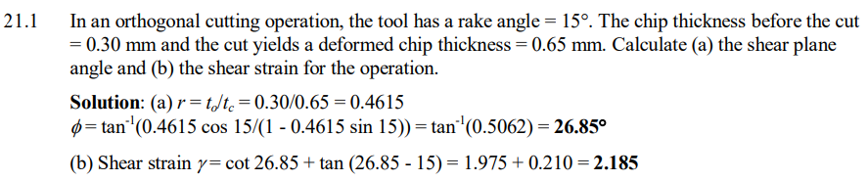

Q3. 21.3

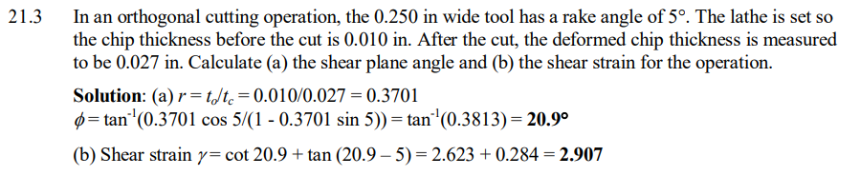

Q4. 21.4

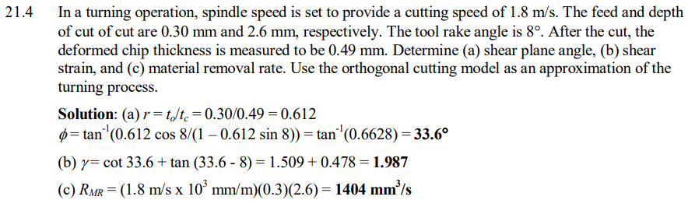

Q5. 21.5

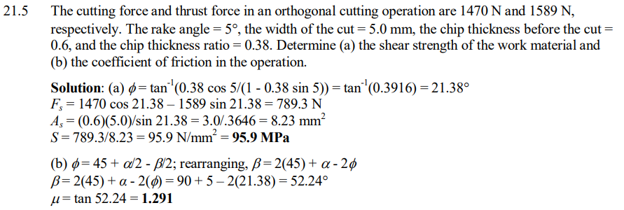

Q6. 21.6

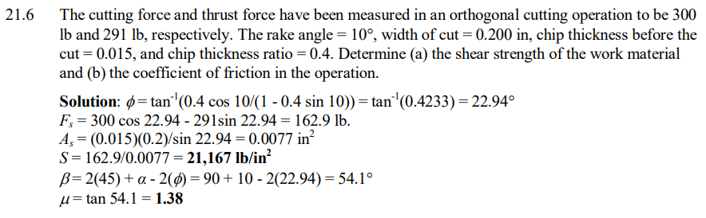

Q7. 21.10

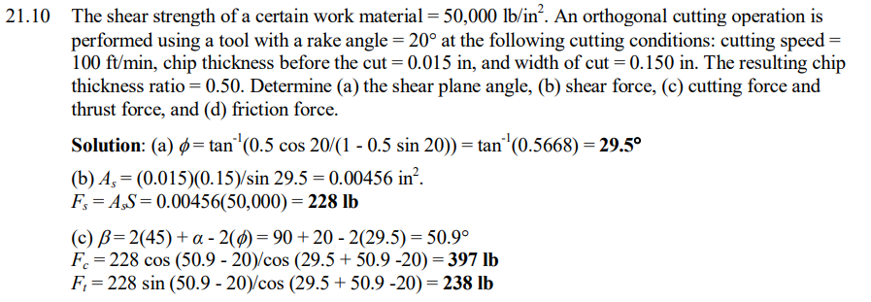

Q8. 21.19

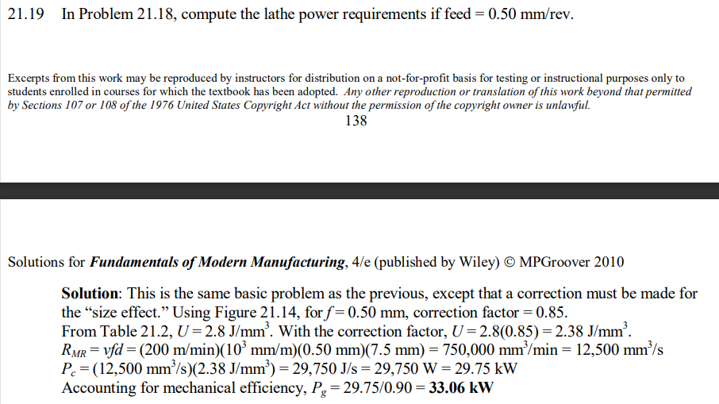

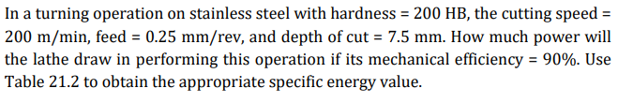

Q9. 21.23

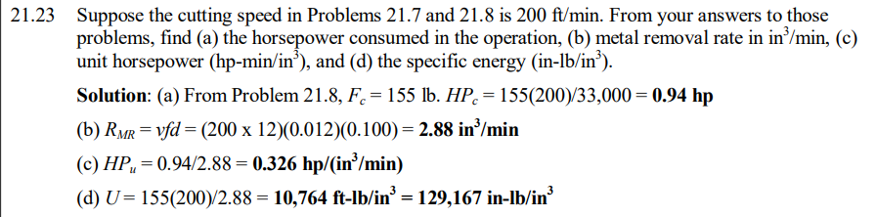

Q10. 21.26

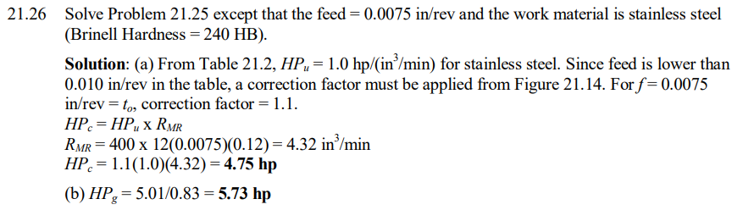

Q11. 22.1

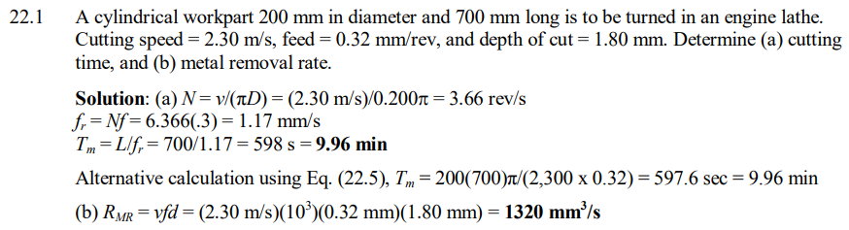

Q12. 22.2

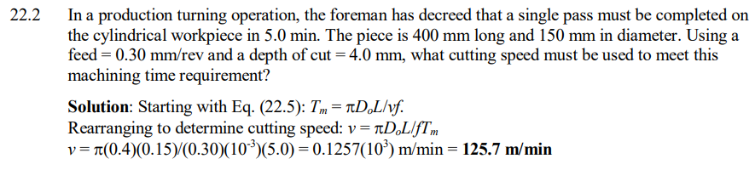

Q13. 22.6

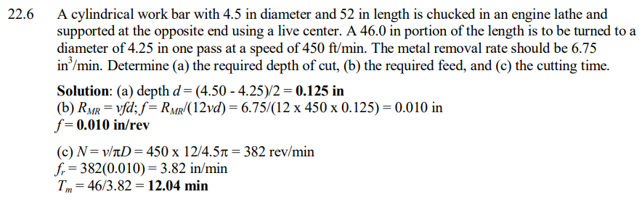

Q14. 22.8

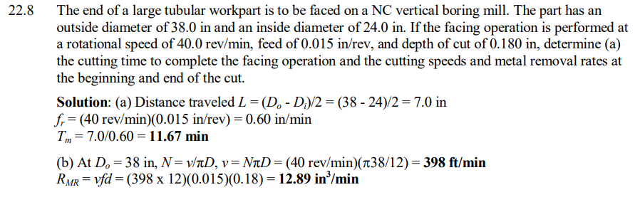



Q15. 22.10

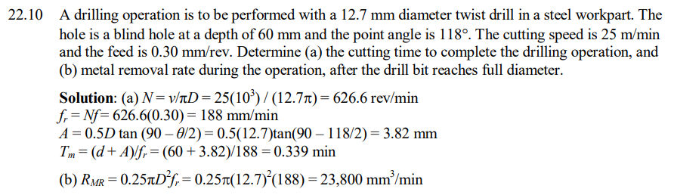

Q16. 22.11

